Planning a Merchandising Strategy in ArcGIS

Lillian Xie

First, I explored demographics and competition in Chicago.

1. Briefly compared the distribution of families, income levels, and home values in the neighborhood of those two Meiers stores.

In terms of the distribution of families, the first store Lombard is surrounded by more families while the second store Pulaski has fewer families nearby, especially on the East side.

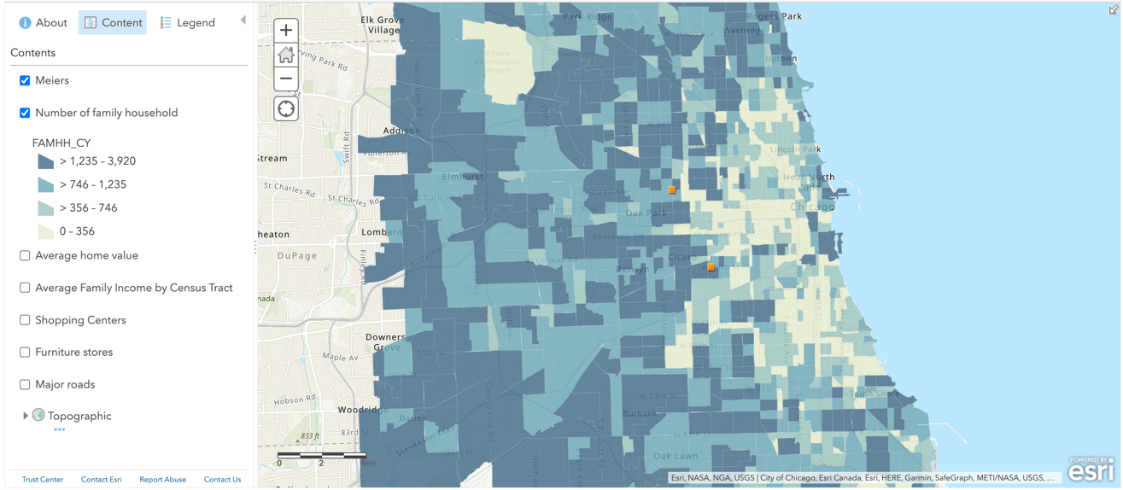

In terms of the family income levels, the first store Lombard is closer to higher income neighborhoods while the area where the second store Pulaski is located has a lower average family income, about 0~$63,620.

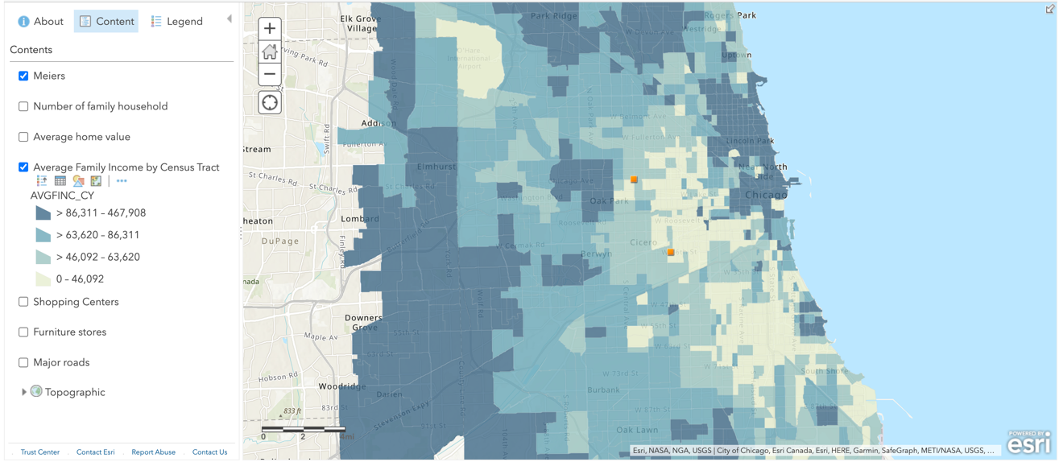

In terms of home values, the houses near the first store Lombard have higher values while houses near the second store Pulaski are priced lower, at about 0~$198,211.

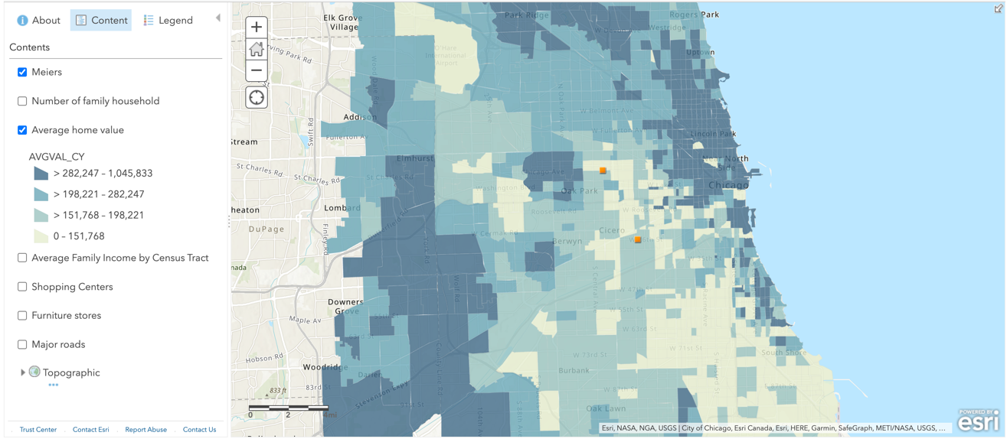

1. Analyzed the location of these two Meiers Home Furnishings stores in terms of:
   1. Shopping centers
   2. Competing furniture retailers
   3. Major roads

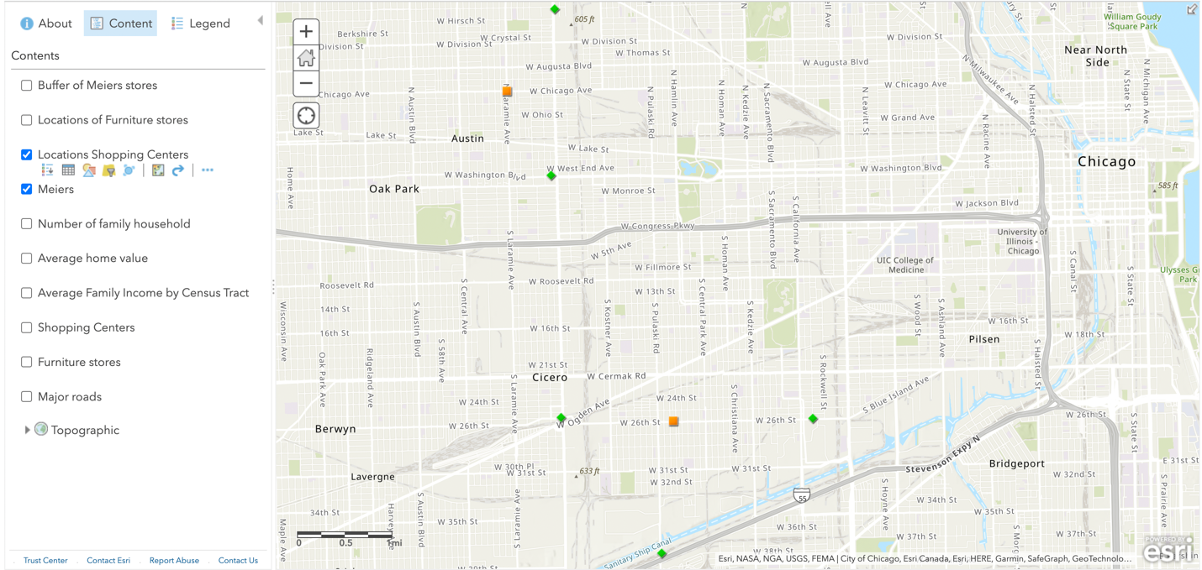

* + 1. A map showing the influence from competing furniture stores

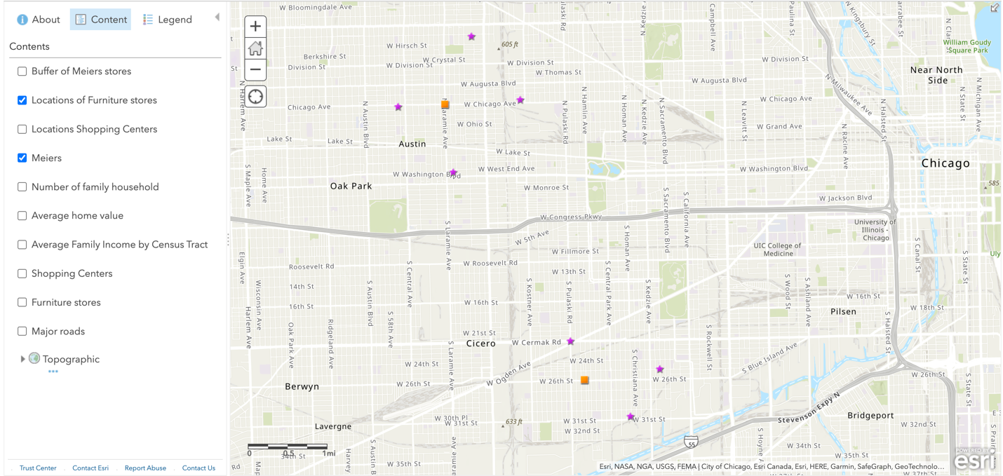

* + 1. A map showing the impact from the type of roads [10 points]

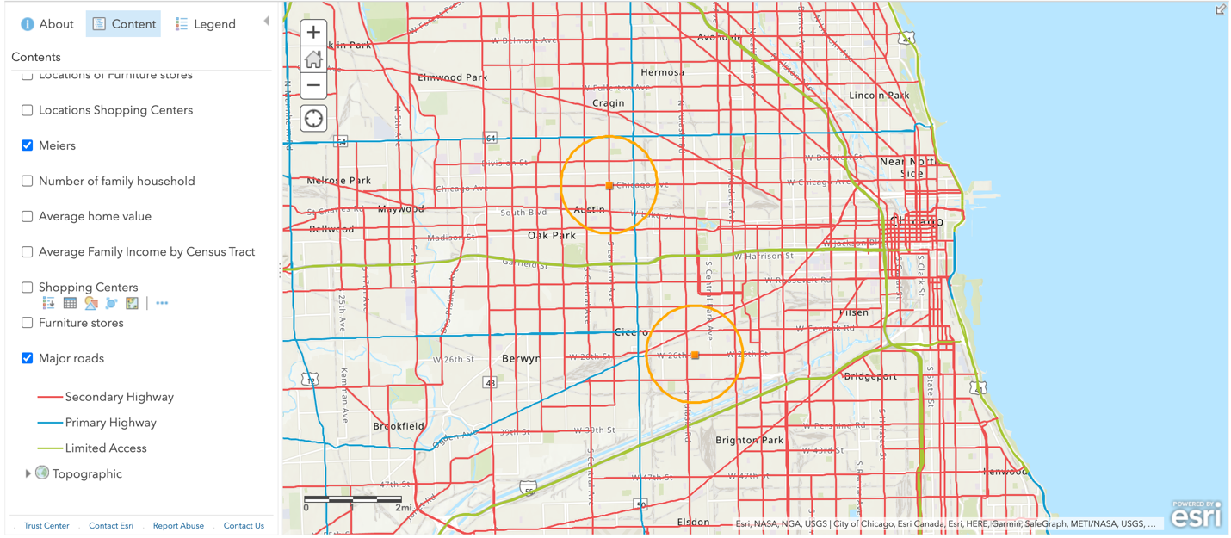

1. Overall recommendations for the poorly performing “Pulaski” store.

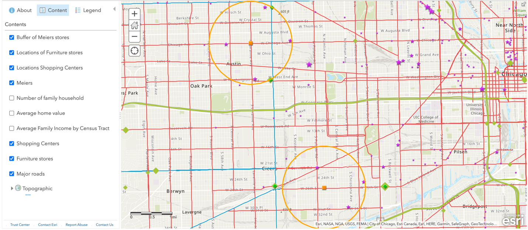

Based on the findings from ArcGIS, there are few recommendations for Pulaski store:

1. Move to the more populated, higher income level area, such as South-Western or North-Eastern Chicago. From the demographic features of the area around the two stores, namely family numbers, home value and average family income, the second store is disadvantageous located, closer to the fewer families, lower income areas and lower home value areas.

2. Move to an area that covers more roads and intersections. The second store Pulaski has less roads within 1mile radius, meaning that it is less convenient to commute to compared to Lombard.

3. Move to an area where the competition between furniture stores is less fierce. Although the second store has more shopping centers around to attract customers, the competitor closely next to it might drive these customers away.